Main Assignment 3: An Analysis of Student Sentiment on The Denison Administration
Zach Barber and Henry Arnold
2025-12-12

1 Introduction
Students form different opinions about campus leaders and student life, and these opinions often come from what they experience on campus in their day-to-day life. When Denison pays attention to these differences, it can get a better sense of how students feel and where improvements might be needed. This kind of understanding can guide decisions about programs, communication, and support services across the university. It also gives Denison a clearer sense of how students fit into campus life and how their daily interactions with classes, activities, and other people influence their overall view of the school. With this in mind, we ask: What factors influence how students feel towards campus administration and student life?

2 Data and Design
For our analysis, we will use the Denison Student Survey, which was conducted in October 2025. This dataset contains responses from a decent chunk of students relative to the total student body, with 419 out of 2394 (roughly 20% of the total student population). Given this percentage, we are confident that our dataset is representative of the total student population. However, there are several caveats with this dataset. First, there was an incentive to complete the survey, being eligible to win one of several gift cards. This means that there is a possibility that some students didn’t pay much attention to the research questions, and answered them as quickly as possible purely to win a gift card. Also, given that this was a Denison survey, some people might not be completely honest with their answers because they feel their responses aren’t entirely anonymous. Even so, even if there are cases of this, we believe that for the most part, students were honest when completing the survey.
The Denison Student survey features 53 unique questions that ask students about topics such as their political ideology, their current opinions of Denison University, and more. Specifically, for our analysis, we will focus on questions that ask students about their nicotine usage habits, their GPA, and their political party affiliation/leaning, to analyze overall campus sentiment toward Denison Student Life (The Campus Administration).

3 Analysis
Students tend to view the Denison Administration positively, which is reflected in the distribution of feeling-thermometer scores in Figure 1. This histogram shows the number of respondents who rated the administration within each decile (range of 10 rating scores). From this visualization, we can see that the ratings do not spread evenly across the scale and many fall in the middle and higher ranges, with a clear cluster around 50. Very few students choose the lowest scores, which shows that strong negative reactions are rare. Overall, the pattern suggests that most students hold neutral to warm impressions of the administration.
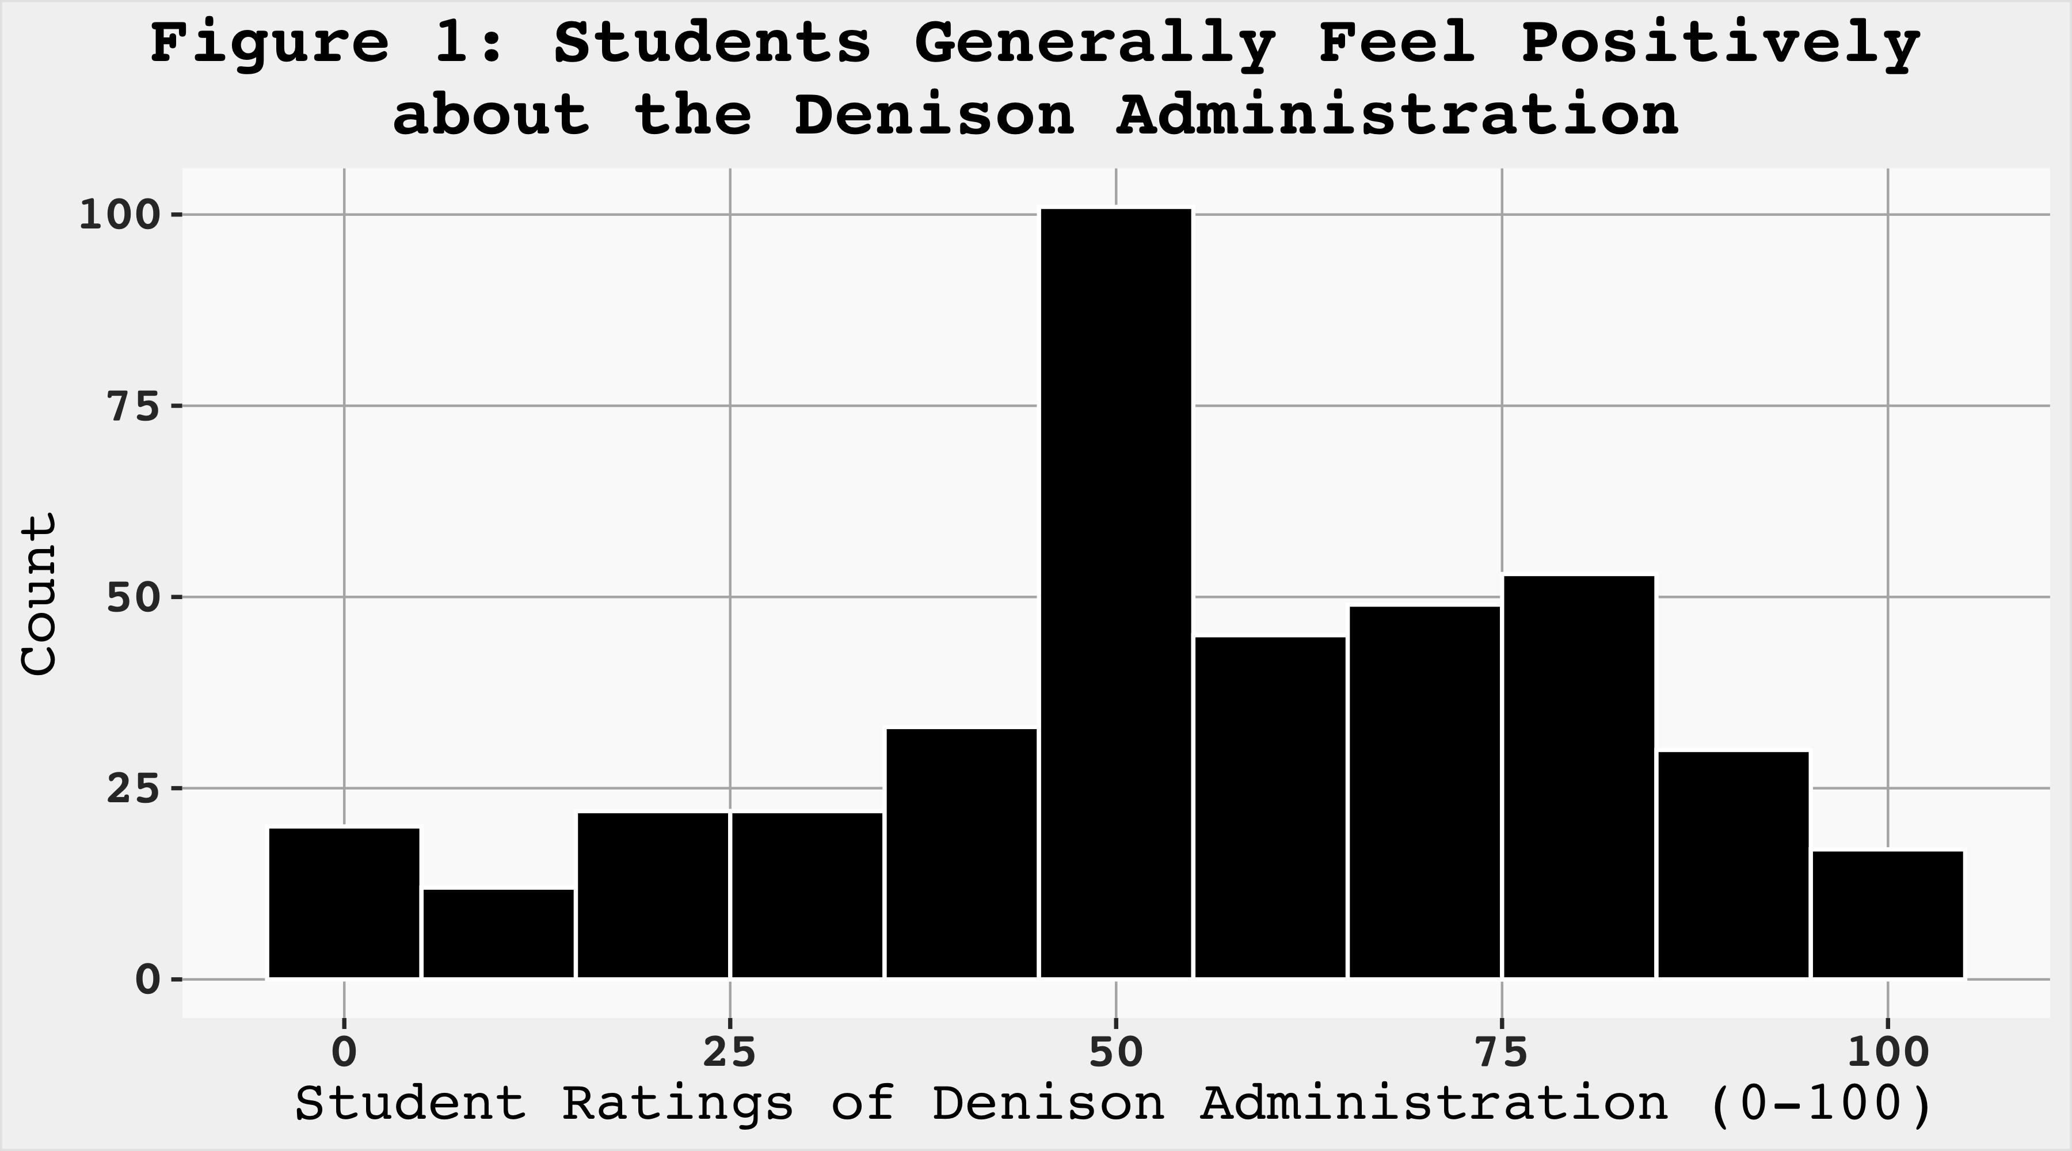
The ridgeline plot seen in Figure 2 shows the distribution of ratings of the Denison Administration grouped by party affiliation. For the purposes of this assignment, we categorized a respondent as a Democrat if they indicated that they lean Democratic on the survey. This corresponds to a response of 1, 2, or 3. We categorized a respondent as a Republican if they indicated they lean Republican on the survey (a response of 5, 6, or 7). Respondents who responded Independent (a response of 4 on the survey) were classified as Independent. The total area beneath each curve is 1, indicating that 100% of respondents in each party categorization rated the administration between 0 and 100. To calculate the proportion of respondents within each category who indicated a score between two rating values, we calculated the area under the curve between the rating values. We found that the proportion of Republicans that indicated a rating of the Denison Administration between 0 and 10 is 0.113, while the proportion for Independents is 0.062, and 0.051 for Democrats. The proportion of Republicans that indicated a rating of the Denison Administration between 90 and 100 is 0.151, while the proportion for Independents is 0.125, and 0.057 for Democrats. Finally, the proportion of Republicans that indicated a rating of the administration between 25 and 75 is 0.472, while the value is 0.562 for Independents, and 0.655 for Democrats. Overall, this suggests that Republicans tend to have more varied or extreme ratings of the Denison Administration compared to Democrats whose views tend to skew more towards the center. Students who identify politically as Independent strike a perfect balance between Republicans and Democrats, skewing more towards the extremes than Democrats, while also skewing more centrally than Republicans
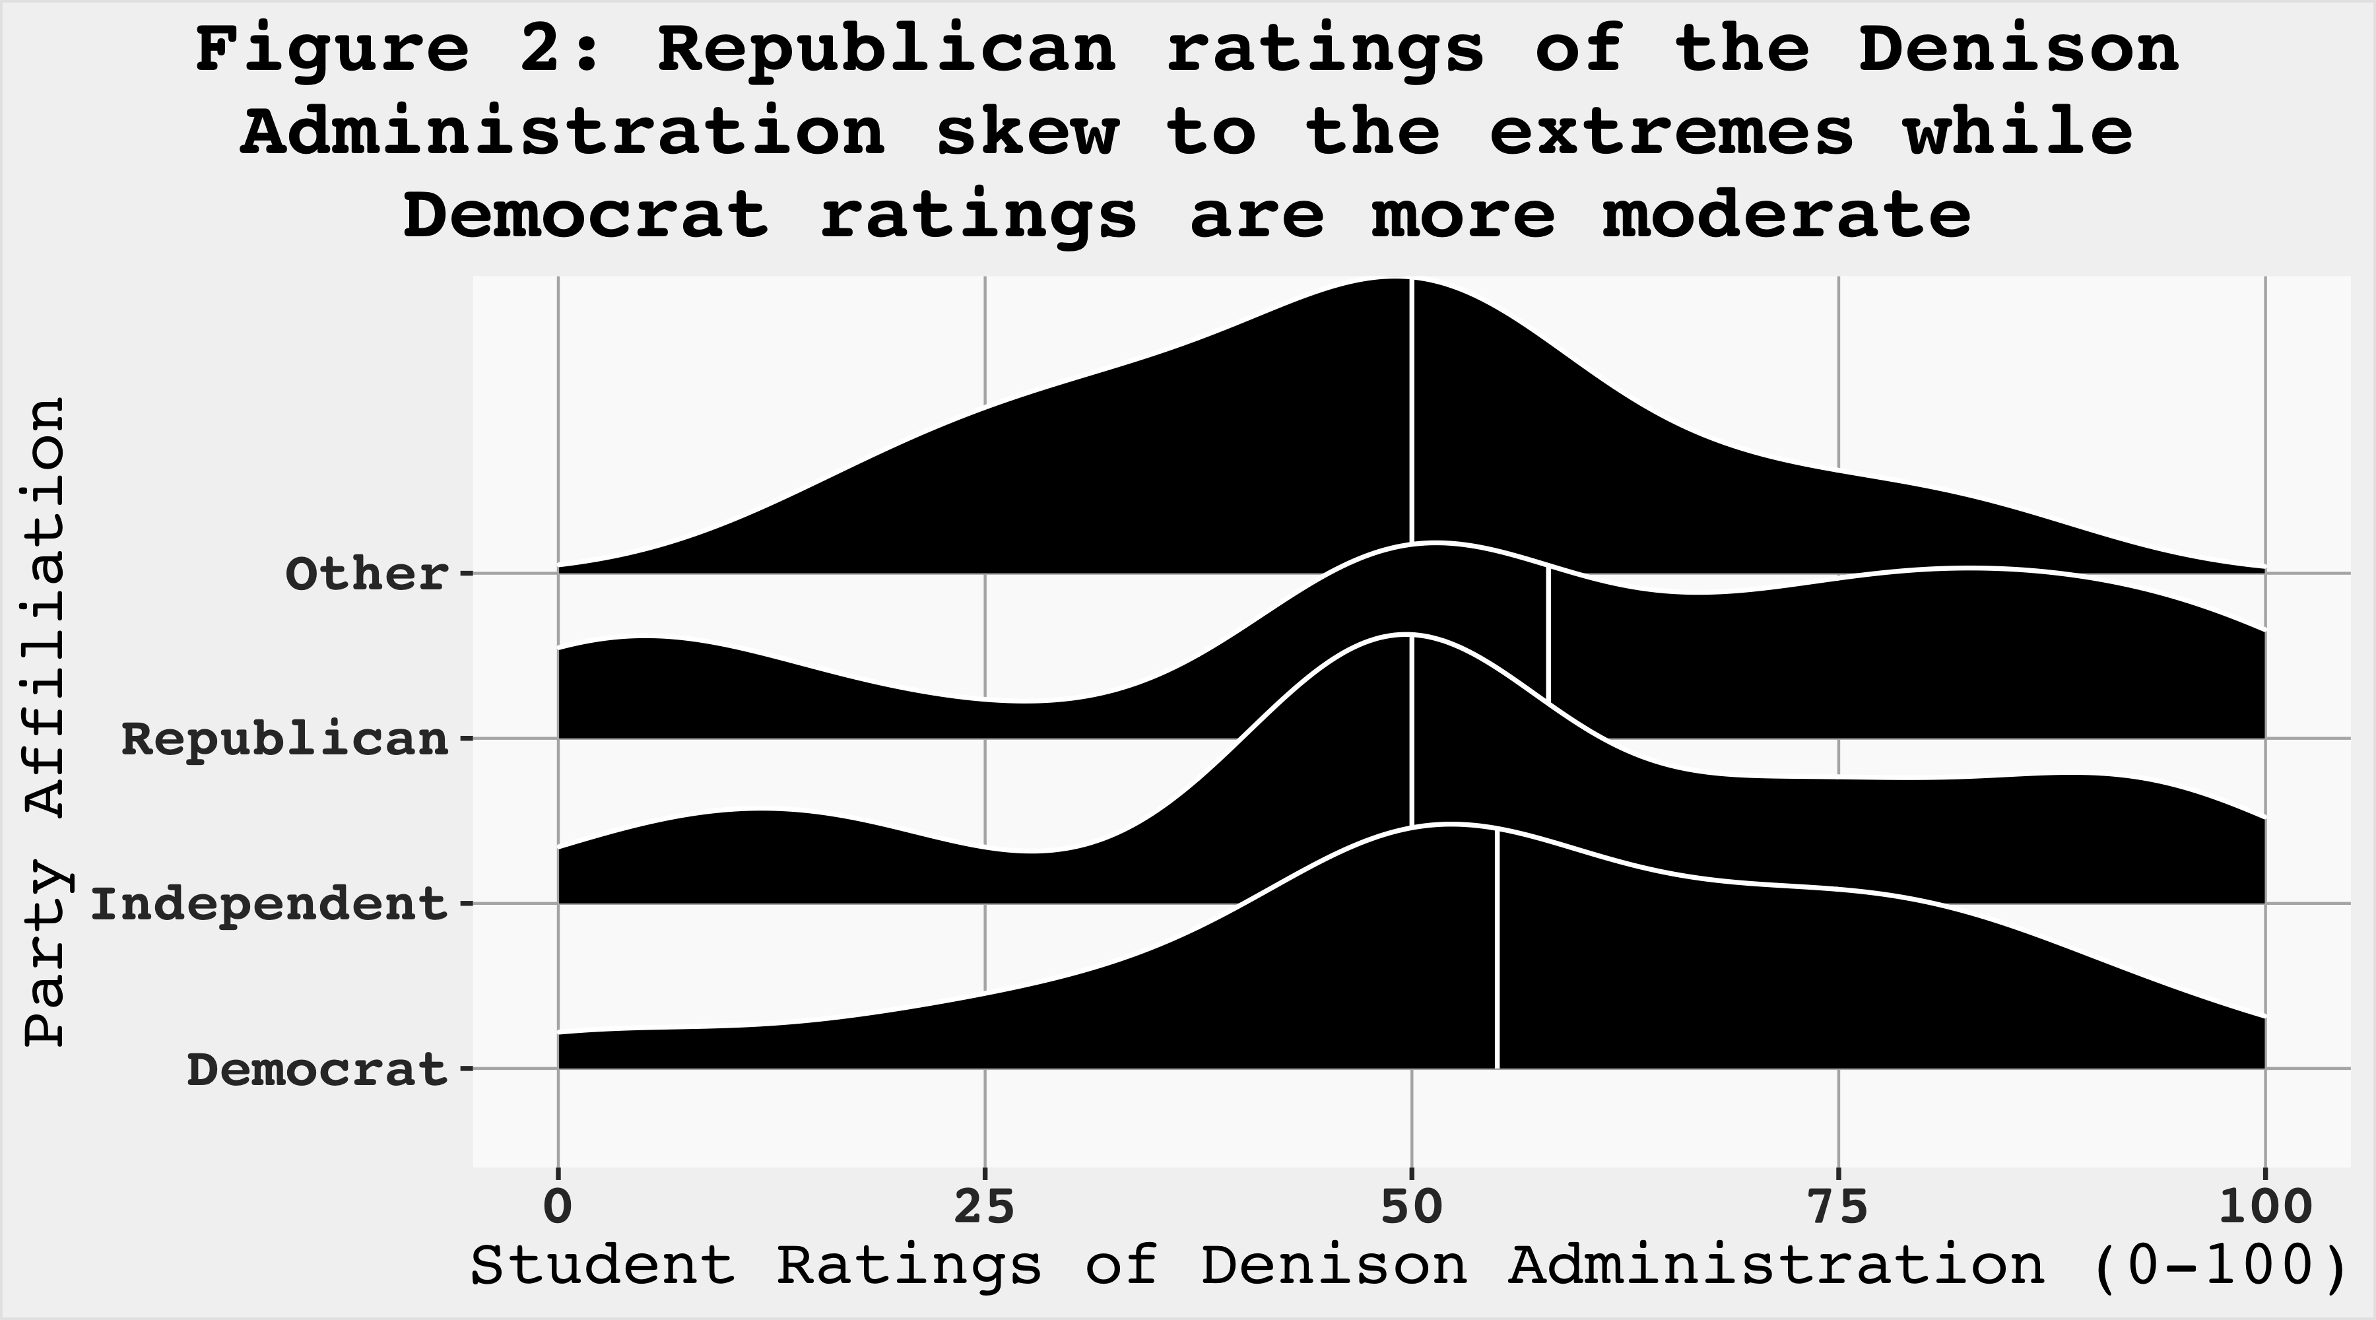
Students who use nicotine tend to rate the Denison Administration more negatively than students who do not use nicotine, as shown in Figure 3. The distribution for students who use nicotine is skewed to the left, and the median of their ratings sits lower than the median of the ratings from students who do not use nicotine. There is also a noticeable number of students who use nicotine who select ratings close to zero, which suggests stronger negative reactions within this group. In contrast, students who do not use nicotine show a wider spread towards the middle and upper parts of the scale, which points to more neutral or positive views overall.
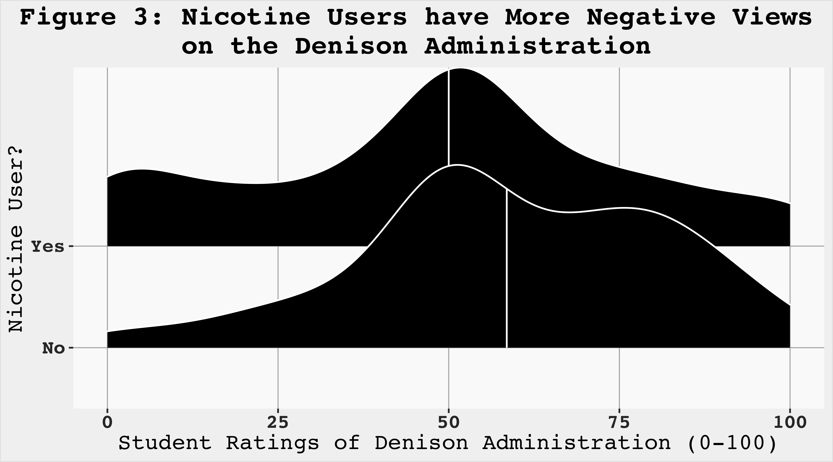
There is no meaningful relationship between GPA and how students rate the Denison Administration, as shown in Figure 4. The scatterplot includes students across the full range of GPAs, and high and low ratings appear randomly throughout the graph rather than forming any clear pattern. Both the linear trend line (shown in red) and the loess curve (shown in blue) stay close to the middle of the scale, which reinforces the idea that academic performance does not have any relation to how students feel about the administration.
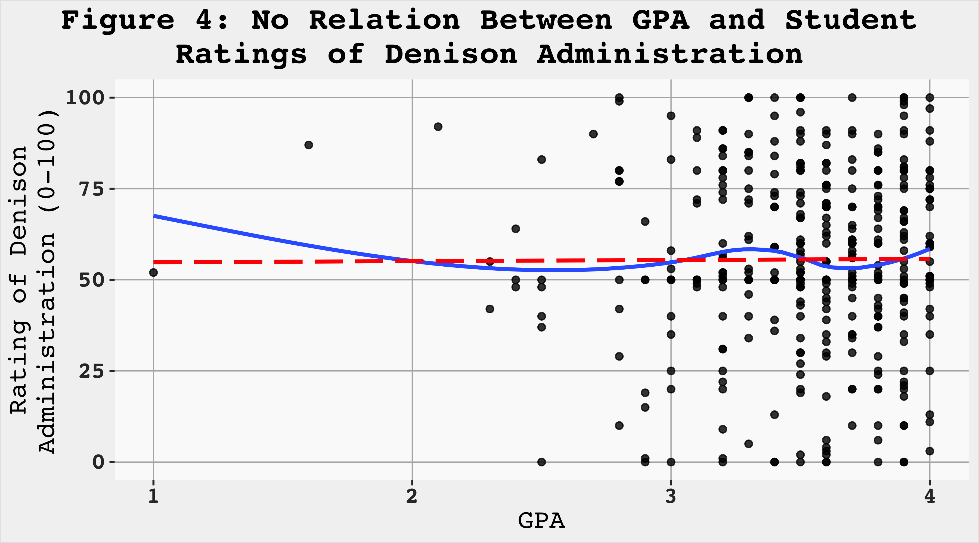

4 Conclusion
Our analysis shows that only some student characteristics meaningfully relate to how students feel about the Denison administration. Nicotine users consistently give lower ratings than students who do not use nicotine, which may suggest that this group feels more targeted by the Denison Administration’s policies, potentially leading to lower student ratings. GPA, on the other hand, shows almost no relationship with students’ views, suggesting that academic performance does not appear to shape feelings toward administrative leadership. Political affiliation does indicate significant differences, with Republican students showing a wider spread of opinions and a higher share of significantly negative and positive ratings. In contrast, Democratic students tend to cluster in more central ranges.
The results indicate that differences in student evaluations of the Denison administration are more closely associated with social and behavioral factors than with academic performance. Notably, there is no clear relationship between GPA and administrative ratings, indicating that satisfaction is not primarily driven by academic outcomes but rather by how students experience the Denison administration’s rules in everyday life. The more negative responses among nicotine users and the polarized views among Republican students suggest that students who feel less aligned with the dominant campus culture are more likely to express dissatisfaction with the Denison administration. Overall, if Denison wishes to improve the appeal of its administration, it should focus on understanding the concerns of nicotine users, and the subset of Republicans who are most unhappy with their performance. By improving their appeal to these specific groups, the administration can greatly improve their overall rating from the Denison population.

5 Code Appendix
# Setup
library(tidyverse)
library(googlesheets4)
library(socsci)
library(ggridges)
library(geomtextpath)
gs4_deauth()
range_speedread(
"https://docs.google.com/spreadsheets/d/1QKpkq8A58MEP2EXvoQPPPjz-WEuXtmIpjAaBGLvpVHc/edit?usp=sharing"
) -> df
# Theme
my_theme <- function() {
ggthemes::theme_tufte(base_family = "mono") +
theme(text = element_text(family = "mono")) +
theme(text = element_text(size = 14)) +
theme(
legend.position = "bottom"
) +
theme(
plot.title.position = "plot",
plot.title = element_text(
hjust = 0.5,
face = "bold"
),
panel.grid.major = element_line(
linewidth = 0.3,
color = "gray70"
),
axis.text = element_text(
face = "bold",
size = 12,
color = "gray20"
),
legend.title.position = "top",
legend.title = element_text(
hjust = .5,
face = "bold.italic",
size = 14,
color = "gray25"
),
panel.background = element_rect(
fill = "gray98",
color = NA
),
plot.background = element_rect(
fill = "gray95",
color = "gray90"
)
)
}
# Manipulation
df_filtered <- df |>
select(ResponseId, Q16_1, Q16_2, Q16_3, Q3, Q38_1, Q13_22)
# Make nicotine user variable that is "Yes" if respondent uses any nicotine products described in survey and "No" otherwise
df_filtered <- df_filtered |>
mutate(
nicotine_user = ifelse(Q16_1 == 1 | Q16_2 == 1 | Q16_3 == 1, "Yes", "No")
)
# Rename variables for clarity
df_filtered <- df_filtered |>
rename(
Q13_Student_Life = Q13_22,
GPA = Q38_1
)
# Make a party affiliation variable based on party leaning indicated in survey
df_filtered <- df_filtered |>
mutate(
party_id = frcode(
Q3 == 1 | Q3 == 2 | Q3 == 3 ~ "Democrat",
Q3 == 4 ~ "Independent",
Q3 == 5 | Q3 == 6 | Q3 == 7 ~ "Republican",
Q3 == 8 ~ "Other"
)
)
df_filtered_party <- df_filtered |>
filter(!is.na(party_id))
df_filtered_reps <- df_filtered |>
filter(party_id == "Republican")
df_filtered_dems <- df_filtered |>
filter(party_id == "Democrat")
df_filtered_ind <- df_filtered |>
filter(party_id == "Independent")
df_party_means <- df_filtered |>
group_by(party_id) |>
summarise(party_mean = mean(Q13_Student_Life, na.rm = T))
# Calcs
rep_10 <- mean(df_filtered_reps$Q13_Student_Life < 10, na.rm = T)
ind_10 <- mean(df_filtered_ind$Q13_Student_Life < 10, na.rm = T)
dem_10 <- mean(df_filtered_dems$Q13_Student_Life < 10, na.rm = T)
rep_25 <- mean(df_filtered_reps$Q13_Student_Life < 25, na.rm = T)
ind_25 <- mean(df_filtered_ind$Q13_Student_Life < 25, na.rm = T)
dem_25 <- mean(df_filtered_dems$Q13_Student_Life < 25, na.rm = T)
dem_IQR <- mean(df_filtered_dems$Q13_Student_Life >= 25 & df_filtered_dems$Q13_Student_Life <= 75, na.rm = T)
rep_IQR <- mean(df_filtered_reps$Q13_Student_Life >= 25 & df_filtered_reps$Q13_Student_Life <= 75, na.rm = T)
ind_IQR <- mean(df_filtered_ind$Q13_Student_Life >= 25 & df_filtered_ind$Q13_Student_Life <= 75, na.rm = T)
rep_90 <- mean(df_filtered_reps$Q13_Student_Life > 90, na.rm = T)
ind_90 <- mean(df_filtered_ind$Q13_Student_Life > 90, na.rm = T)
dem_90 <- mean(df_filtered_dems$Q13_Student_Life > 90, na.rm = T)
rep_75 <- mean(df_filtered_reps$Q13_Student_Life > 75, na.rm = T)
ind_75 <- mean(df_filtered_ind$Q13_Student_Life > 75, na.rm = T)
dem_75 <- mean(df_filtered_dems$Q13_Student_Life > 75, na.rm = T)
ggplot(df_filtered) +
aes(x = Q13_Student_Life) +
geom_histogram(binwidth = 10, color = "white", fill = "black") +
labs(
title = "Figure 1: Students Generally Feel Positively\nabout the Denison Administration",
x = "Student Ratings of Denison Administration (0-100)",
y = "Count"
) +
my_theme()
ggplot(df_filtered_party) +
aes(x = Q13_Student_Life, y = party_id) +
stat_density_ridges(
aes(height = ..density..),
quantile_lines = T,
quantiles = 2,
geom = "density_ridges",
fill = "black",
color = "white") +
scale_x_continuous(limits = c(0, 100)) +
labs(title = str_wrap("Figure 2: Republican ratings of the Denison Administration skew to the extremes while Democrat ratings are more moderate", 45),
x = "Student Ratings of Denison Administration (0-100)",
y = "Party Affiliation") +
my_theme()
ggplot(subset(df_filtered, !is.na(nicotine_user))) +
aes(x = Q13_Student_Life, y = nicotine_user) +
stat_density_ridges(
aes(height = ..density..),
quantile_lines = T,
quantiles = 2,
geom = "density_ridges",
fill = "black",
color = "white") +
scale_x_continuous(limits = c(0, 100)) +
labs(
title = str_wrap("Figure 3: Nicotine Users have More Negative Views on the Denison Administration", 50),
x = "Student Ratings of Denison Administration (0-100)",
y = "Nicotine User?"
) +
my_theme()
ggplot(df_filtered) +
aes(x = GPA, y = Q13_Student_Life) +
geom_point(alpha = .8) +
geom_smooth(method = "loess", se = F) +
geom_smooth(method = "lm", linetype = 5, se =F, color = "red") +
labs(title = str_wrap("Figure 4: No Relation Between GPA and Student Ratings of Denison Administration",50),
x = "GPA",
y = "Rating of Denison\nAdministration (0-100)") +
my_theme()

